Part A
What type of test (Boundary or expected/Unexpected | Test Input | Expected output | Actual Output | Pass/Fail | If it fails (Y/N) | What did you do to fix it | Screenshot Evidence
Expected/Unexpected | N/A | To ask for test scores | Syntax error | F | Y | I will try and find the error by going over the coding till I notice a problem and fix it | 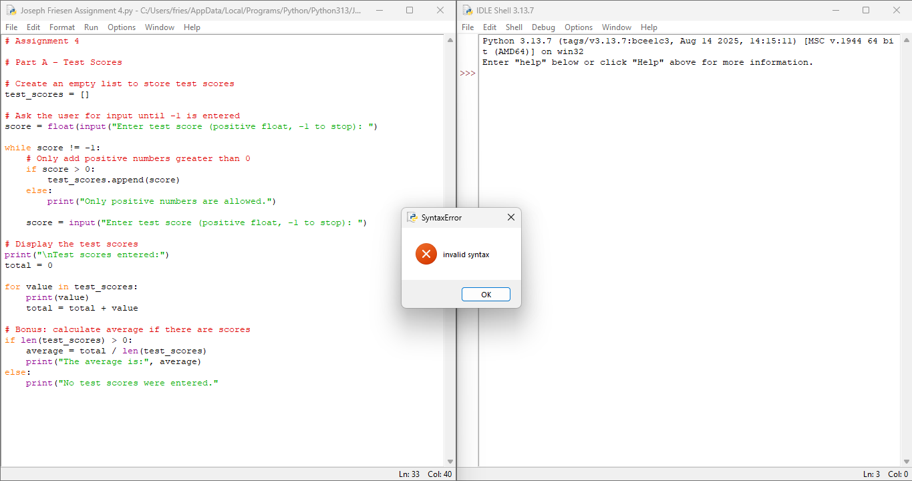
Expected/Unexpected | N/A | To ask for test scores | Syntax error | F | Y | In line 18 I forgot the float before and some “(, and )” but now I got another error so I ill try and find that | 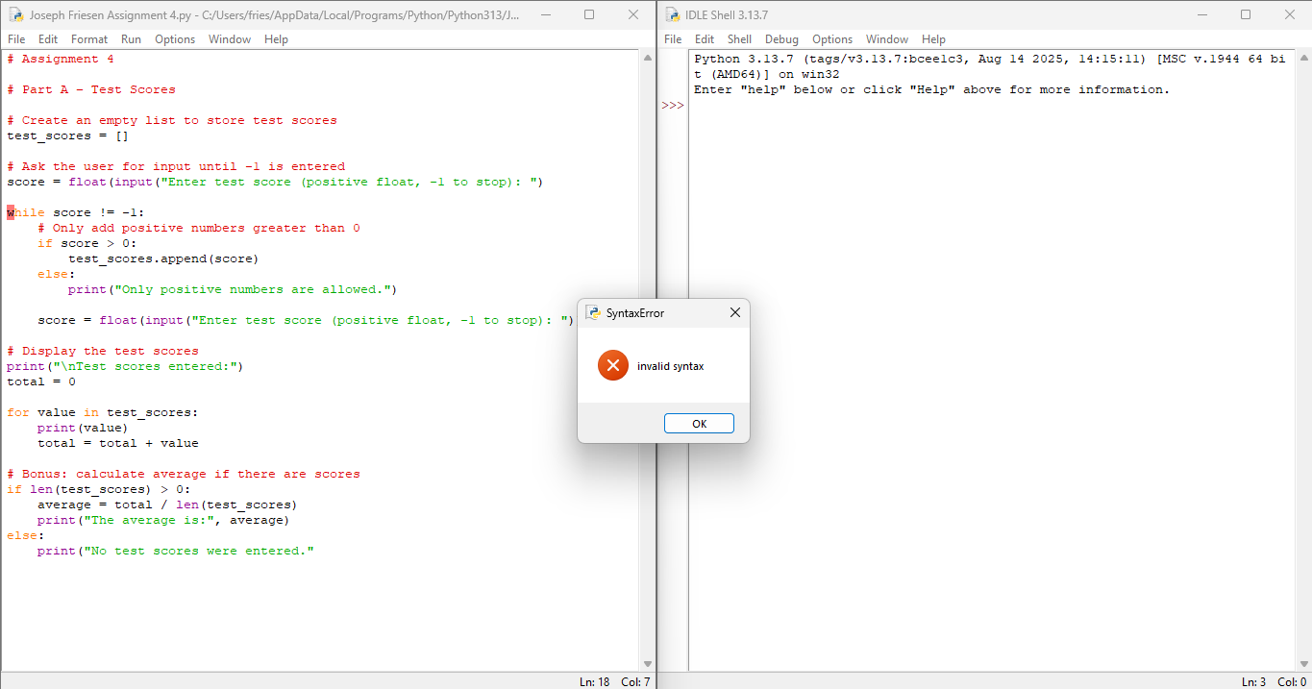
Expected/ Unexpected | 4  8  4 | To ask for test scores | It asked for test scores | Pass | N | I found a few more errors but I fixed them all | 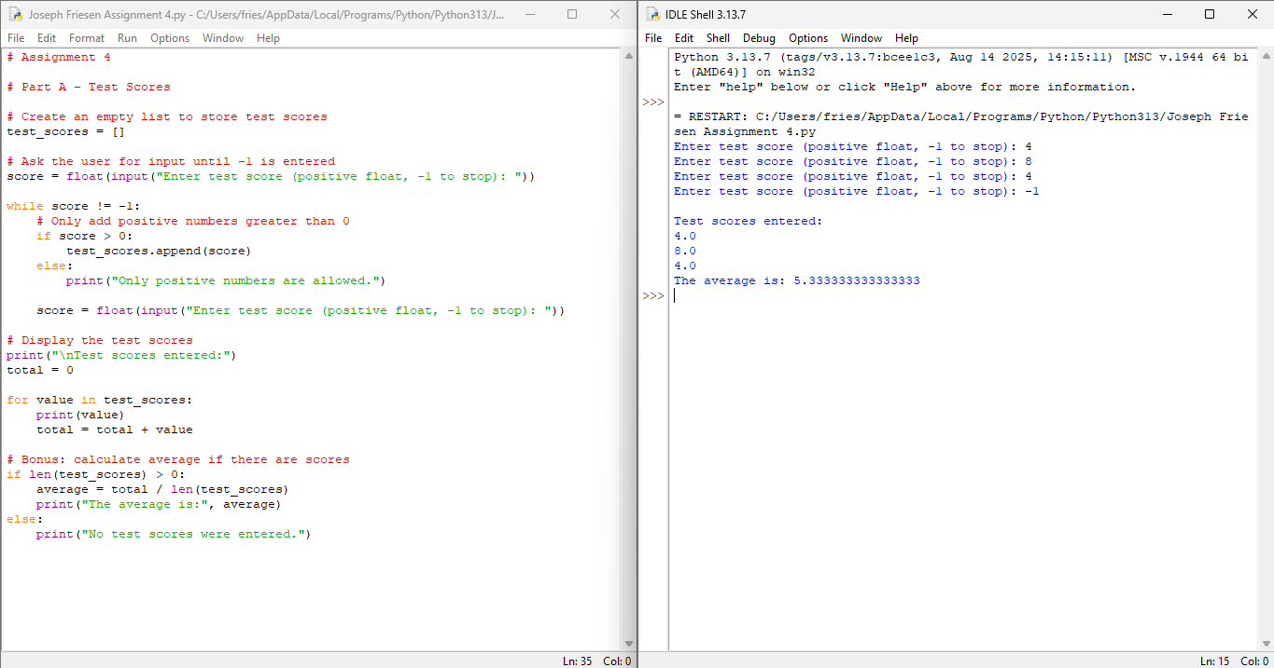
Boundary | 1  -2  9  -1 | To ask for test scores | It did what I thought | Pass | N | It showed the score beside the -2 | 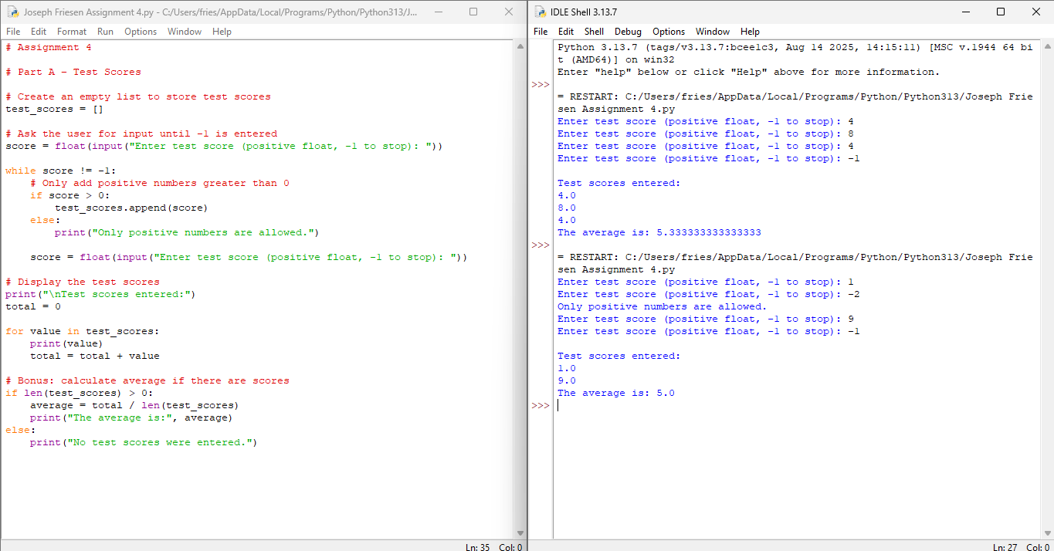

Part B
What type of test (Boundary or expected/Unexpected | Test Input | Expected output | Actual Output | Pass/Fail | If it fails (Y/N) | What did you do to fix it | Screenshot Evidence
Expected/ Unexpceted | Pizz  NOODLE  Icecream  Pie | To say the item wasn’t in the list | It gave an error when I checked if the item was in the system | fail | y | I will take out the float function and see if it helps | 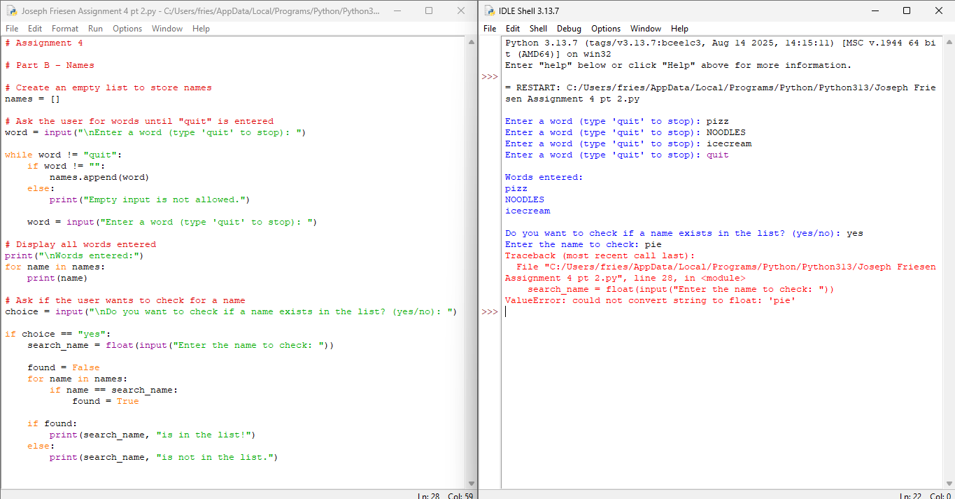
Boundary | One  Two  Three  four | To say the item wasn’t in the list | It did what I thought | Pass | N | N/A | 